Day 1

Task 1

1. Compare Dual core vs Quad core.

A dual core processor has two CPU cores on a single chip and these processor can execute two tasks simultaneously. But in quad core processor has four CPU cores on a single chip. Dual core processor is better than single core and it can handle multitasking and casual gaming. Quad core is handle four tasks simultaneously and it can significantly boast performance for multitasking and demanding applications.

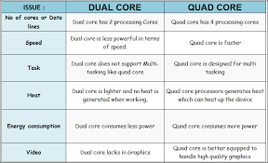

2. Explain Intel (i5 and i7).

Intel i5.

Intel i5 processors come with several notable features. They typically have multiple cores, which allow them to handle multiple tasks simultaneously, resulting in improved multitasking capabilities. Additionally, they often support Intel Turbo Boost technology, which dynamically increases the clock speed of the processor when needed, providing a boost in performance for demanding tasks.

Intel i7.

The Intel Core i7 processor is a high-performance processor designed for demanding computing tasks. It features multiple cores, high clock speeds, and advanced features such as hyper-threading and turbo boost.

